The TCP Server

Javier Bermejo EA1AUS, Aki Yoshida JA1NLX, and Rick Williams VE7TK

1.0 GENERAL

The TCP Server provides an interface to the evaluation version of JTDX (a program written by UA3DJY for Digital modes JT65, JT10, T9, and WSPR-2).

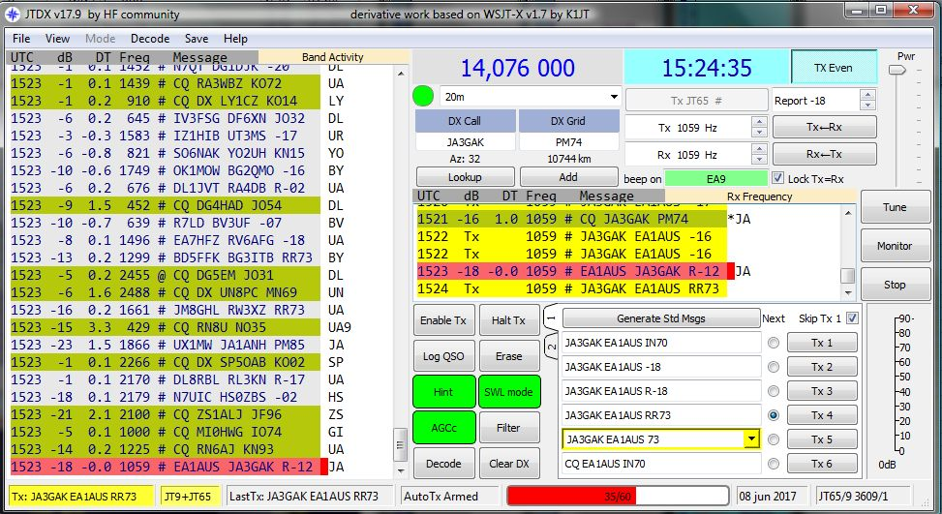

TCPS_1

This is a bridge between Logger32 and JTDX. When the port of TCP Server is opened in Logger32, any JTDX QSO data for the modes listed above can be transferred automatically to Logger32, and Logger32 will log this QSO in the current Logbook.

The following site is to download the latest stable version of JTDX and online help.

http://www.qrz.lt/ly3bg/JTDX/jtdx.html

2.0 Configuration.

2.1 Configuration in Logger32

  - Open the TCP Server from “View” option in main menu of Logger32 and Click File.
  - Click to Close Port : Click to close port or open port
  - Popup on connect:: The TCP Server window appears when it is connected to client if this option is checked.
  - Hide: Click to hide TCP Server window.
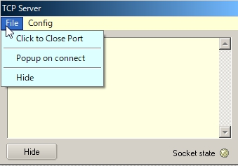

TCPS_2

Click Config to see the Host ID (PC name for this PC), the Local IP, the IP address (for this PC) and port number.

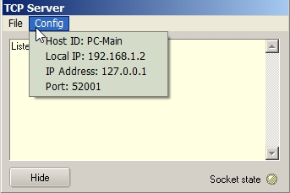

new TCPS_3

The Socket state LED shows port/connection status .

  - Red: Port is closed;
  - Orange: Port is opened but no connection established (or no connection request from JTDX); and
  - Green: Connection established while JTDX is sending QSO data.

This status is also displayed in the lower status bar.

Move the cursor to the TCP pane. If the port is opened the text is highlighted with Blue color. If the port is closed the text is highlighted with Red color.

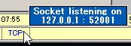

new TCPS_3A

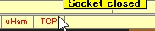

TCPS_3B

Right click on the TCP pane to show the Server menu.

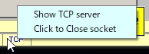

TCPS_3C

2.2 Configuration in JTDX

JTDX may be installed not only in the same PC as Logger32 but diffrent PC if both PC are connected with LAN.

Open the Reporting tab on JTDX settings, look for External logbook connection section. You see “127.0.0.1” as TCP Server and “52001” as TCP Port. These are default values.

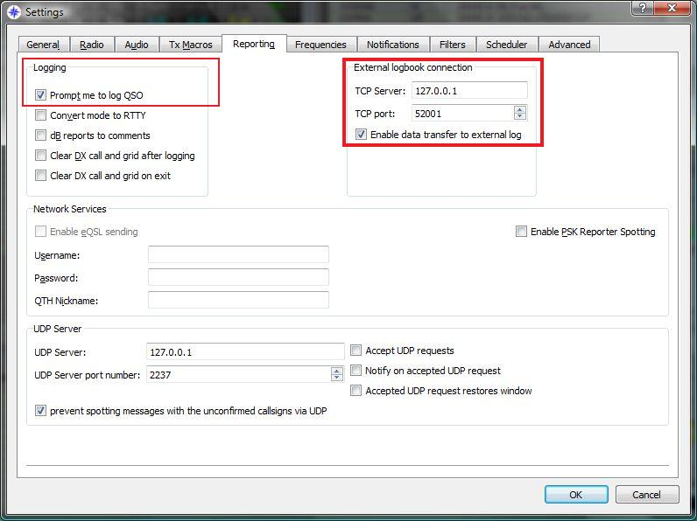

TCPS_4

If JTDX is installed in the same PC as Logger32 then leave TCP Server and TCP port as they are. If JTDX is installed in the different PC then type Local IP as TCP Server address which you see in Logger32 TCP Server. (TCPS_3) Leave TCP Port as it is. In this case TCP Server tooltips is displayed like this once connection is established.

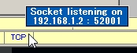

TCPS_4A

Check "Enable data transfer to external Log" option.

It's preferable to also check "Prompt me to log QSO" in Logging section. This way whenever we send a goodbye message, we will see the QSO data waiting to be transfered to logger32.

Click OK to save settings.

The following graphic shows the fields of the QSO waiting to be transferred to Logger32.

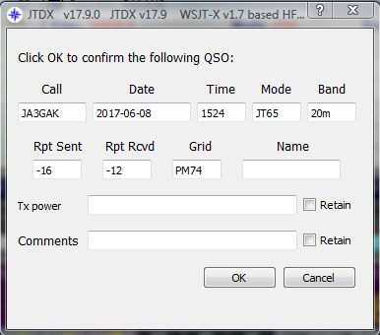

TCPS_5

3.0 OPERATION

Open the TCP Server using the View menu item of the Main menu in Logger32 and open the port. (Next time you start Logger32, this action will be remembered)

Log the QSO in JTDX. QSO data are momentarily displayed in Blue text in the TCP Server window. This QSO is logged automatically in the current Logger32 Logbook. Example of traffic received through the TCP Server is shown below.

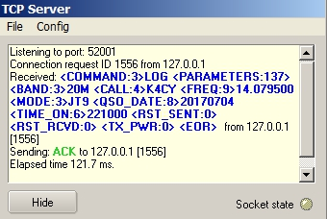

new TCPS_6

4.0 Tips

4.1 Logbook synchronization

If you want to synchronize both Logbooks in Logger32 and JTDX then try following steps.

If your Logger32 logbook already contains JT65 and/or JT9 QSOs:

(1) In Logger32 export a PARTIAL log containing your JT65 and JT9 QSOs.
(2) Name the exported file wsjtx_log.adi and save it to a safe location.
(3) Replace the default wsjtx_log.adi file located in c:\user/name/AppData/Local/JTDX with the new file exported from Logger32.

Importing the data from YOUR Logger32 logbook will ensure that JTDX has updated DXCC / Mode and QSO data and will flag the calls heard correctly.

4-2 Connection errors

If you receive the JTDX error message "Socket operation timeout" or "Host not found" then try following steps.

(1) Close/Open TCP port

(2) Look at IP address displayed in Config menu and lower status bar. Type this IP address in JTDX TCP Server box.

